- Financial markets breathed a sigh of relief this week as the US and Iran announced a two-week ceasefire. However, the truce looks fragile and the Strait of Hormuz is still effectively closed, so we don't plan any major changes to our UK growth and inflation projections as part of our global forecast update on April 13.
- The week's only major data release, the S&P Global services survey, reported a sharp pickup in input cost inflation and weaker growth in activity. But history suggests the survey is better thought of as a barometer of corporate sentiment than a leading indicator of activity. It will be a while until we have a better handle on the impact of the conflict on activity.
As the Middle East conflict has progressed, we've made the point that the military and diplomatic timeline differs from the economic one. This week's events were a good demonstration of that dynamic. On Tuesday evening, the US and Iran announced a two-week ceasefire agreement. While this is a positive development, the truce has failed to completely halt fighting across the region, confusion remains over the exact terms of the ceasefire, and the Strait of Hormuz is still effectively closed.
Nevertheless, financial markets reacted positively. Brent Crude one-month futures fell around $15 per barrel to $95 after the news broke, with only a slight reversal of this move in the days since. Elsewhere, the prospect of lower commodity prices meant gilt yields fell fractionally, with most of the movement seen at the short-end of the curve. Meanwhile, market expectations for Bank Rate shifted downwards (Chart 1).
The ceasefire lessens the chances of more disruptive outcomes playing out. But even if a full-blown truce is agreed, it will take time for energy production and shipping traffic to return to normal levels. Our current baseline assumption is that the Strait of Hormuz remains effectively closed until the end of April, with traffic levels rising to around 50% in May and June, before gradually recovering to normality over the following six months. This week's news is consistent with those assumptions.
Chart 1: Short-dated yields and Bank Rate expectations fell in response to the ceasefire announcement
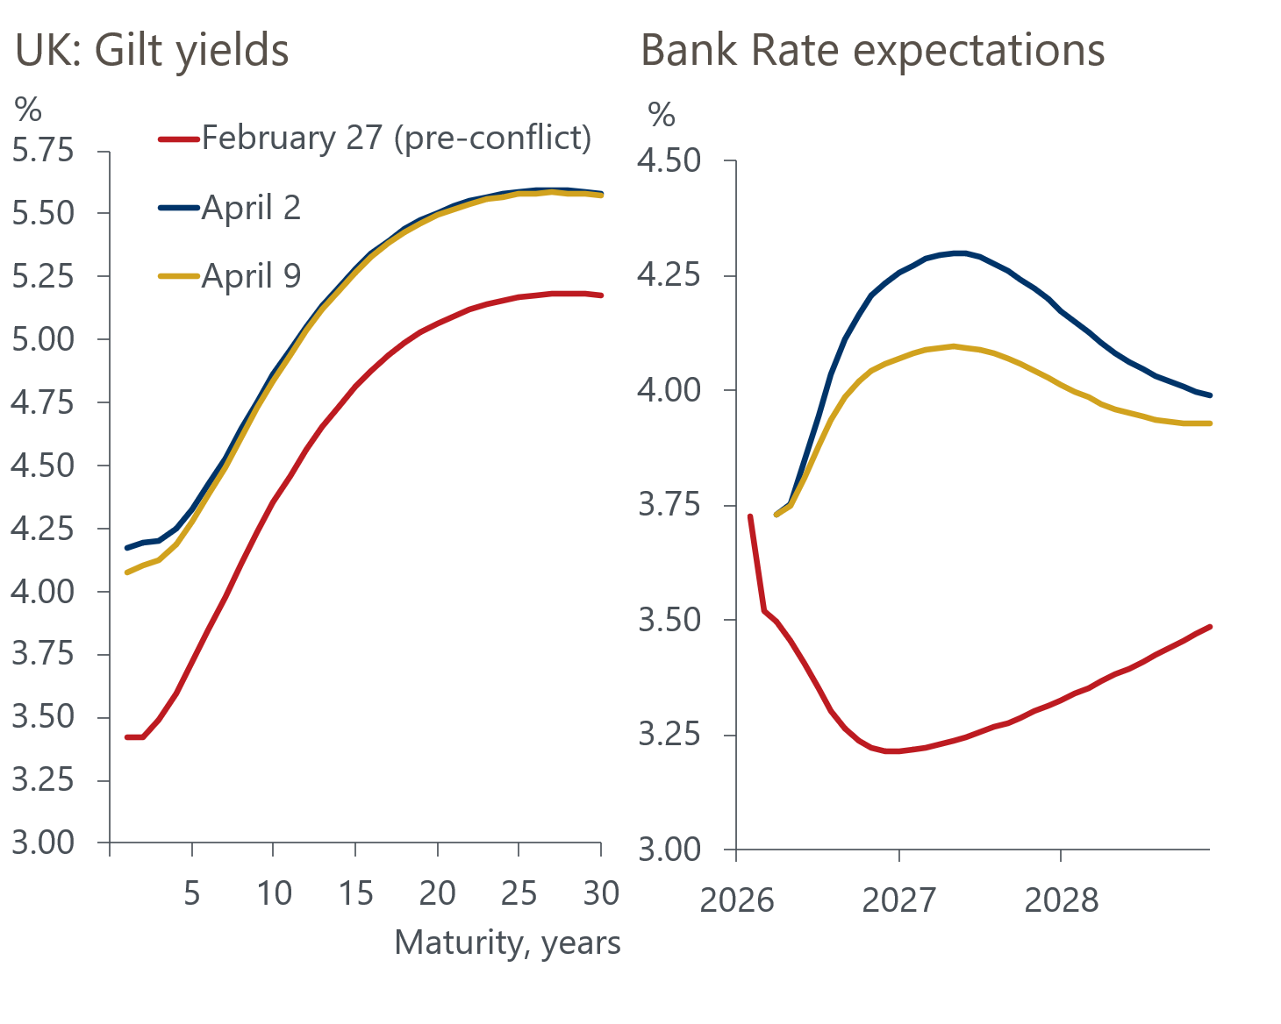
Sources: Haver Analytics

So our updated baseline UK forecast, which will be published on April 13 as part of our global update, will continue to assume commodity prices remain elevated this quarter, before a slow normalisation. As such, our projections for GDP growth and inflation over the next couple of years will be little changed from our previous baseline.
Since the outbreak of the Middle East conflict, the Bank of England's Monetary Policy Committee has been in a holding pattern, as it awaits more information about the nature of the energy shock and the degree to which it is feeding through to the domestic economy. We're set to hear from several MPC members next week, including Governor Andrew Bailey, which will likely be the last substantive comments before committee members enter their quiet period ahead of their next meeting at the end of this month.
One factor complicating the picture for policymakers is that while signs of mounting price pressures are materialising relatively quickly, clear evidence of the impact of the conflict on activity is likely to take longer to emerge.
This week's S&P Global services survey signalled that firms experienced a sharp rise in input cost inflation in March, and despite some margin compression, service providers started to reflect these increases in the prices charged to customers.
Yet March's survey also suggested that services activity continued to grow, albeit at a more modest pace than in previous months. However, we've long argued that the S&P Global surveys should be seen as indicators of corporate sentiment rather than as leading indicators of activity. Our analysis finds that the relationship between the survey's results and official GDP growth is tenuous at best (Chart 2). Therefore, beyond pointing to a deterioration in private sector confidence, this week's survey provided little steer on how activity is actually responding to the conflict.
Chart 2: The predictive capability of the PMIs remains very weak
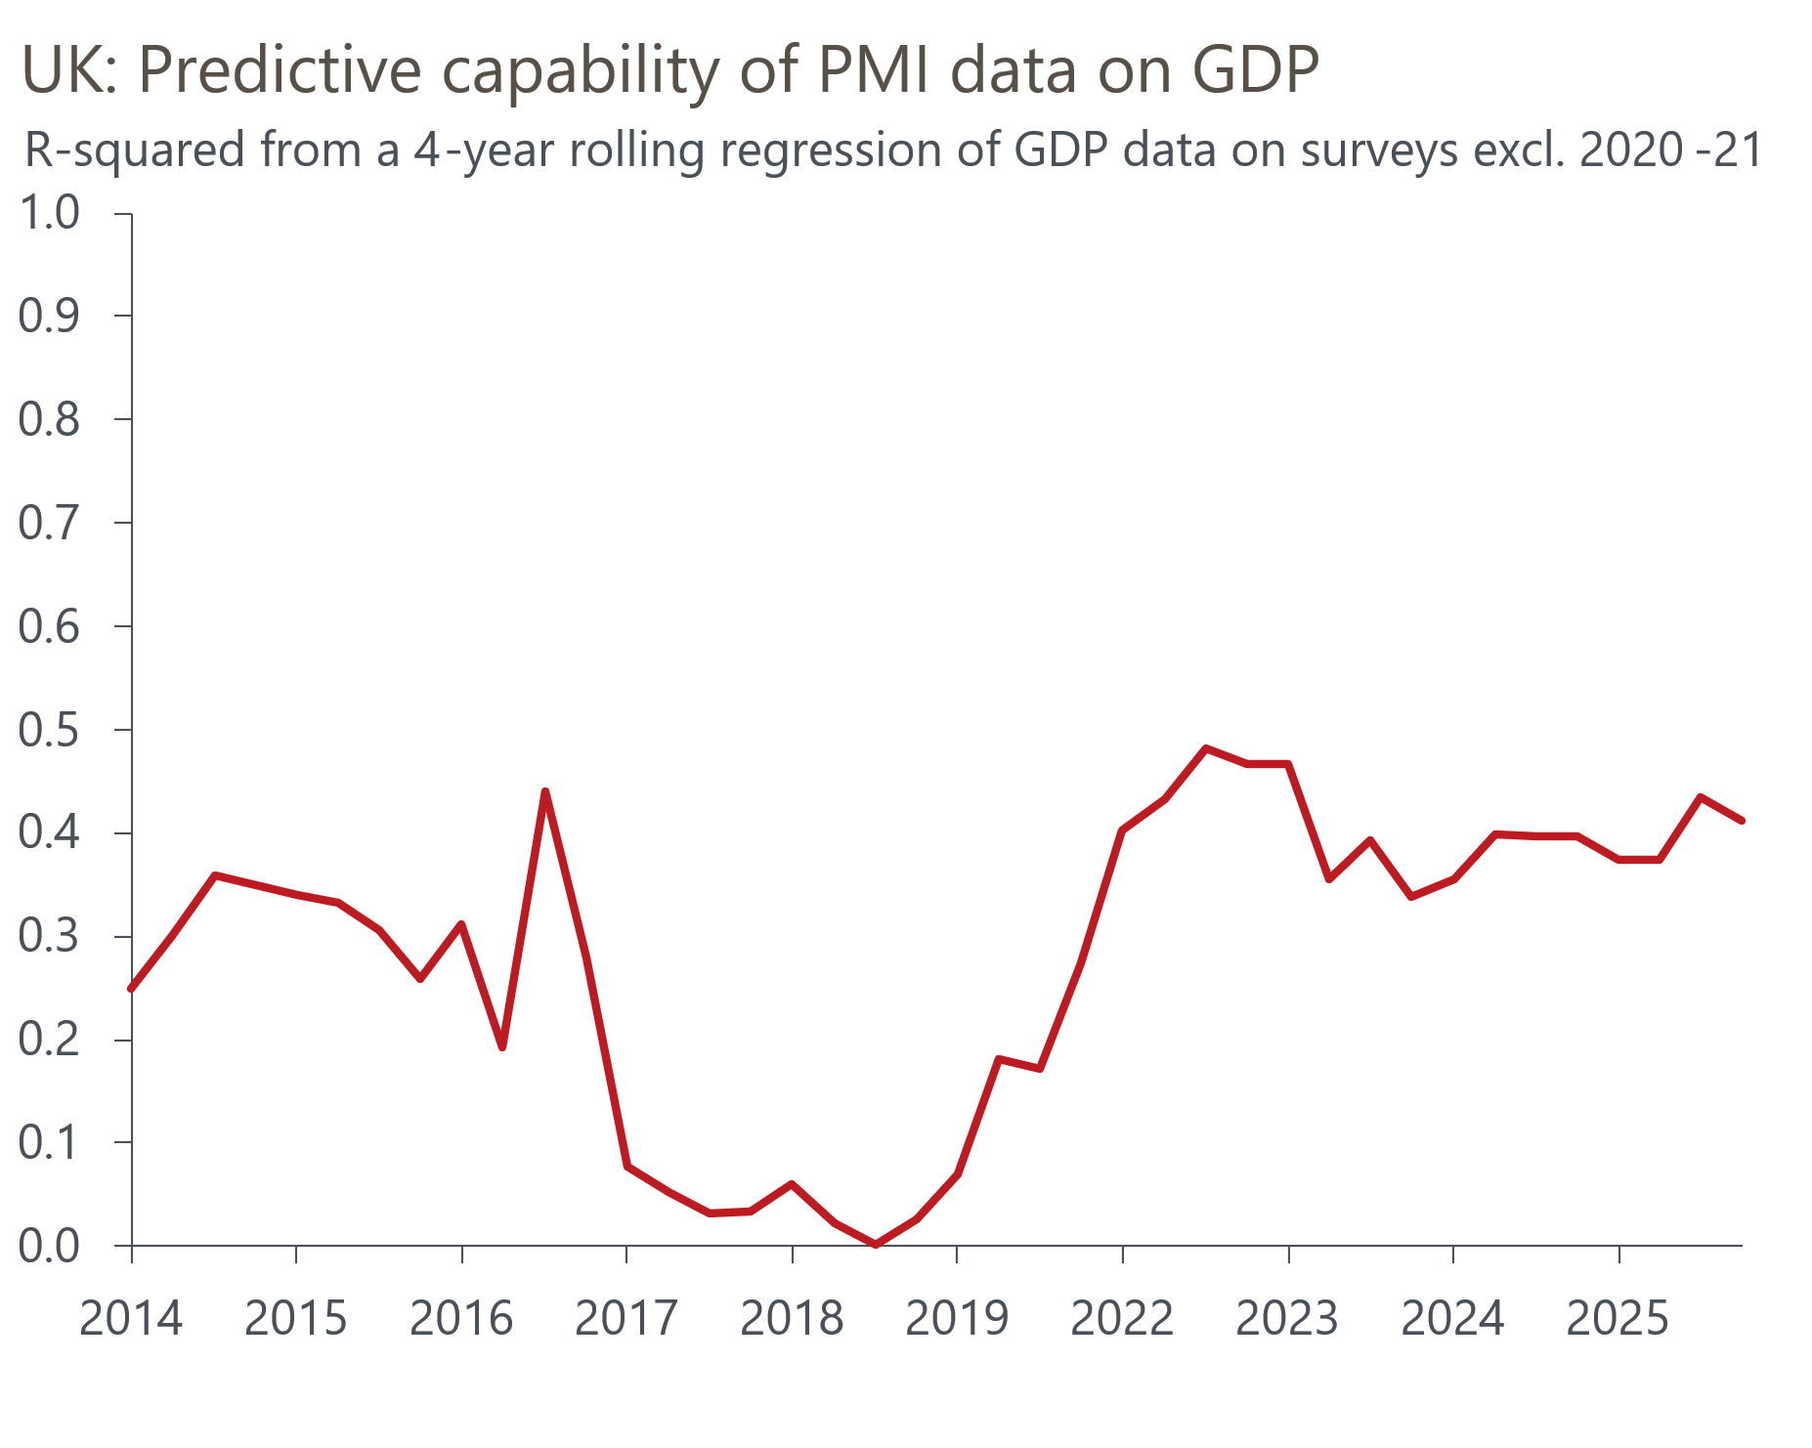
Source: Oxford Economics calculations using data from Haver Analytics and S&P Global

The week ahead
Thursday will see the release of GDP data for February. Output was unchanged in January, as unusually weak outturns across several industrial and non-consumer-facing parts of the services sector dragged on activity. While there's a good chance these moves unwound in February, we see scope for weaker consumer-facing services activity to have an offsetting effect. So on balance, we think GDP remained flat for the second consecutive month in February.
Table 1: Week ahead calendar
Date | Events | Period | Measure | Unit | Previous | Forecast
Apr 16 | GDP | Feb | m/m | % | 0.0 | 0.0
Apr 16 | GDP | Feb | 3m/3m | % | 0.2 | 0.3
Apr 16 | Index of services | Feb | m/m | % | 0.0 | 0.0
Apr 16 | Index of services | Feb | 3m/3m | % | 0.2 | 0.2
Apr 16 | Manufacturing output | Feb | m/m | % | 0.1 | 0.2
Apr 16 | Manufacturing output | Feb | y/y | % | 1.3 | -0.3
Apr 16 | Industrial production | Feb | m/m | % | -0.1 | 0.3
Apr 16 | Industrial production | Feb | y/y | % | 0.3 | -0.9
Apr 16 | Construction output | Feb | m/m | % | 0.2 | 0.1
Apr 16 | Construction output | Feb | y/y | % | -0.1 | -0.3
Apr 16 | UK trade | Feb | Trade balance | £bn | 3.9 | -2.0
Apr 16 | UK trade | Feb | Visible balance | £bn | -14.4 | -20.3
Source: Oxford Economics

Key forecasts
Table 2: UK forecast overview
(Annual percentage changes unless specified)
 | 2023 | 2024 | 2025 | 2026 | 2027 | 2028
GDP | 0.3 | 1.1 | 1.4 | 0.4 | 0.9 | 1.8
Private consumption | -0.3 | -0.1 | 0.8 | 0.3 | 0.5 | 1.5
Fixed investment | 0.5 | 1.8 | 4.3 | 0.2 | 1.4 | 2.6
Government consumption | 2.1 | 2.9 | 1.7 | 1.9 | 1.6 | 1.4
Exports of goods and services | -2.3 | 1.3 | 2.1 | 0.9 | 0.4 | 1.5
Imports of goods and services | -1.6 | 2.7 | 4.1 | 0.4 | 0.3 | 1.2
Industrial production | -2.6 | -1.6 | -0.3 | 1.3 | 0.6 | 1.4
Consumer prices | 7.3 | 2.5 | 3.4 | 3.9 | 2.6 | 1.7
Unemployment rate (%) | 4.1 | 4.3 | 4.9 | 5.4 | 5.5 | 4.9
Current a/c balance (% of GDP) | -3.6 | -3.0 | -2.4 | -3.7 | -3.2 | -2.7
Government balance (% of GDP) | 5.2 | 5.2 | 5.1 | 4.2 | 3.6 | 2.9
Central bank policy rate (%, EOP) | 5.25 | 4.75 | 3.75 | 3.75 | 3.50 | 3.00
10yr govt. bond yield (%, EOP) | 3.54 | 4.57 | 4.47 | 4.74 | 4.21 | 3.83
Exchange rate (US$ per £, EOP) | 1.27 | 1.25 | 1.35 | 1.29 | 1.30 | 1.30
Exchange rate (euro per £, EOP) | 1.15 | 1.21 | 1.15 | 1.11 | 1.10 | 1.10
Source: Oxford Economics
Table 3: Quarterly forecasts for the UK
 | 2025 |  |  |  | 2026
 | Q1 | Q2 | Q3 | Q4 | Q1 | Q2 | Q3 | Q4
GDP (% year) | 1.8 | 1.4 | 1.3 | 1.0 | 0.5 | 0.4 | 0.3 | 0.4
CPI inflation (% year) | 2.8 | 3.5 | 3.8 | 3.4 | 3.0 | 3.6 | 4.4 | 4.5
Bank Rate (%, EOP) | 4.50 | 4.25 | 4.00 | 3.75 | 3.75 | 3.75 | 3.75 | 3.75
10yr gilt yield (%, EOP) | 4.70 | 4.48 | 4.70 | 4.47 | 4.88 | 4.80 | 4.78 | 4.74
US$ per £ (EOP) | 1.29 | 1.37 | 1.35 | 1.35 | 1.32 | 1.31 | 1.30 | 1.29
Euro per £ (EOP) | 1.20 | 1.17 | 1.15 | 1.15 | 1.14 | 1.14 | 1.12 | 1.11
Source: Oxford Economics

Latest Country Economic Forecast:
March 20, 2026

Recent publications

Data Insights
Middle East war hit confidence in the services sector in March
Manufacturing PMI weighed down by Middle East conflict
National accounts confirm soft performance over H2 2025
Mortgage activity is likely to weaken in the near term
February's retail data partially corrected after January's surge

Research Briefings
MPC hunkers down
MPC preview – Middle East war takes March cut off the table
How will central banks respond to the Iran conflict?
OBR forecasts were out of date before they were published
Productivity may be picking up – but not in a good way

Contacts

Oxford Economics' UK team
- Andrew Goodwin - Chief UK Economist - agoodwin@oxfordeconomics.com
- Edward Allenby - Senior UK Economist - eallenby@oxfordeconomics.com

